VBSA Team Photo Gallery – Help file
About the VBSA team photo gallery
The Index page
- As items are created and images are uploaded the index page will automatically pick up the year entered and display it as one of the linked pages
- The years will be displayed descending or newest first.
- When an item is entered it will automatically create an ID number. Always use this number for reference.
- Items are auto inserted as “Current = Yes”, this means they will be displayed on the website. If you wish to “Archive” an item set “Current =No” The item will then not appear on the website but will appear in the “Archives”
- To edit the information section at the top of the page simply click the  image, it will take you to the edit page. On completion of editing when you click the update button it will return you to the “Index” page
Detail page (this is the page that appears when you click the “View All” link)
- This page will display ALL photos that have been uploaded to this year
- Photos will be displayed in order of “Season” S1 then S2 and then ordered alphabetically by Grade eg A Billiards, A Snooker, B Snooker, B Reserve Snooker etc.
- To edit any item simply click the image, it will take you to the edit page for that item. On completion of editing when you click the update button it will return you to the “Index” page.
Inserting a new item
- When working with photos it is advisable to take a “Copy” of them first. You do not want to save edited files over your originals or you may lose your original copy.
- You will need your photos saved on your computer as you will be asked to “Browse” to find them to upload. Suggest you save your copied original as a “Thumbnail or Proof” in a separate folder before you begin uploading. Images must be less than 100kb in size or you will get an error when you try to upload.
- You MUST insert a year or the page will show an error
Archive page
- This page will show all items that have “Current” set to “No”.
- To make an item visible again set Current = Yes

Using the text editor
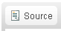
Allows the user to see the html or website code. WARNING unless you are proficient in html please do not use this feature.
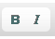
Bold or italicise text

Change font colour. Please use sparingly and do not use blue as this is the default colour for links
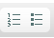
Create a bulleted or numbered list

Indent or reduce indent text
Paste as plain text. Handy when you have copied formatted text from another source.
Paste a block of text from word. Word has its own method of formatting. If you copy directly you will bring in a lot of unwanted formatting that may cause errors on the page.
Spell checker
Create a link or remove a link – See next page for instructions

Undo, Redo, Find or replace

Creating a link
Create an Email link
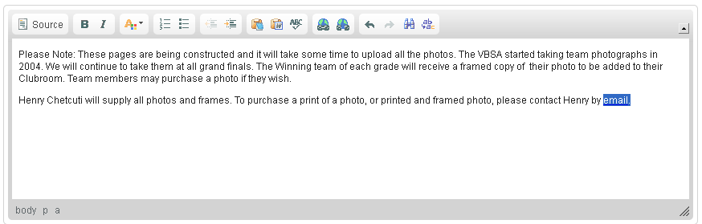
Highlight the text you wish to create an email link from and click the button, a popup menu will come up
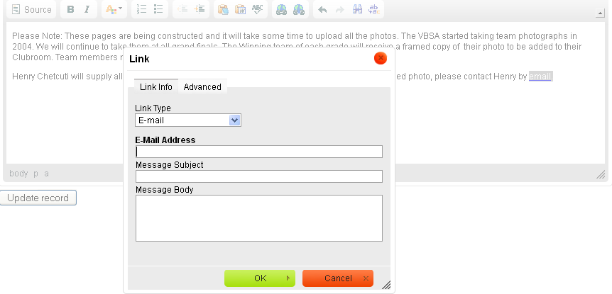
Select the “Link Type” E-mail and Fill in the appropriate fields with the email address, message subject if you want and click “OK” your link has been created.
To remove the link, highlight the text that carries the link and press the right hand of these two buttons
To edit the link, highlight the text that carries the link and press the left hand of these two buttons

To create a link to a web page
Before you begin, go to the web page you wish to create a link to and copy the “URL” in the address bar of your browser.
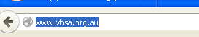
Select the web address and copy it to your clipboard
Highlight the text you wish to create the link from and click the button
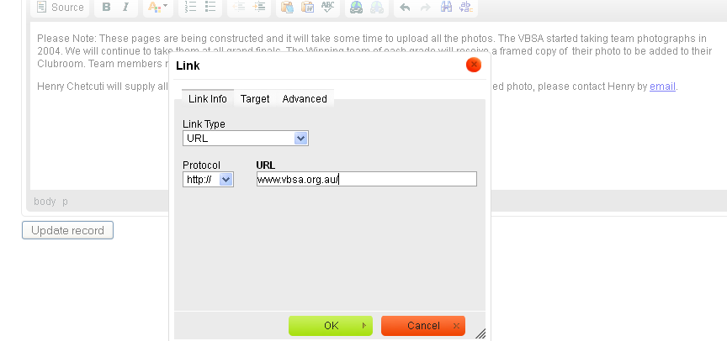
Paste the copied URL you have on your clipboard INTO the URL box
IMPORTANT
Now click the “Target” link
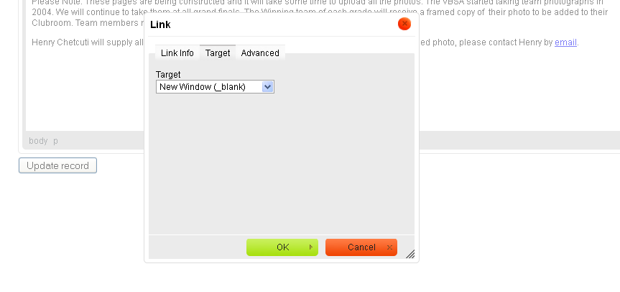
And set the target to New Window (_blank) this means when the user clicks the link it will open a new window in their browser and will not take them away from the site

